SECURITY NOTICE · ISPS CODE OPS-VIS-ISPS-01 · Rev 1.0
Keep 2 metres clear along the fence
Terminal perimeter · Delivery Team, Supervisors and Clerks
PERIMETER FENCE | The empty strip is between the fence and the yellow line.  Everything you put down goes on the yard side of the line. The strip against the fence stays empty, all day, every day.
2 m — KEEP EMPTY
YARD — STACK HERE

1 | Nothing between the fence and the yellow line  No cargo. No equipment. No materials. No vehicles.

2 | Keep the full 2 metres clear  The line is painted at 2 metres. Stack and park on the yard side of it.

3 | Found something inside? Move it out now  Do not wait to be told. Then report it to your supervisor.

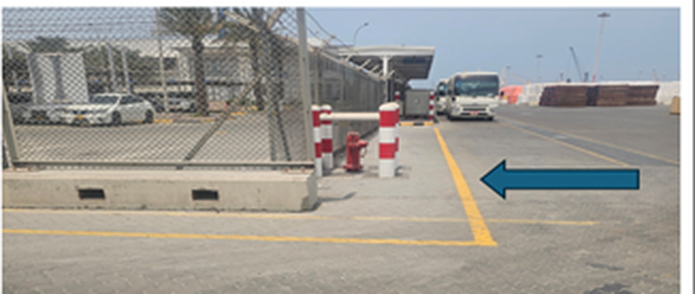 | 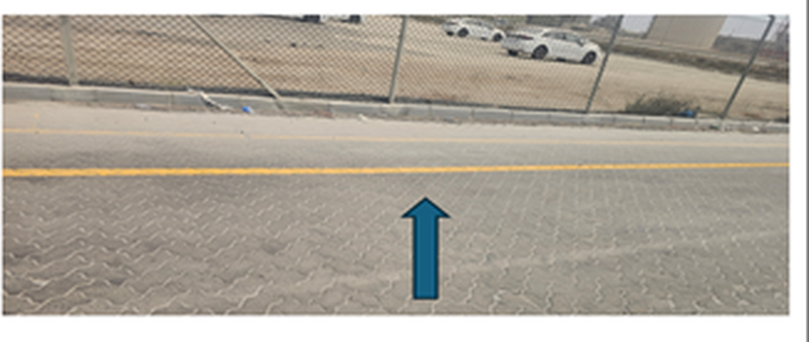
Arrow points at the strip. It stays empty. | Same rule on the open yard. Fence side is clear.
On the terminal layout the zone is marked in red; on the ground it is painted in yellow. Two colours, one zone — outside you will only ever see the yellow line, and that is the one to work to. The area is checked regularly against the ISPS Code.

